Task Application is a web application developed with Spring Data, Thymeleaf, HTML/CSS and Java programming language. The data is stored in a MySQL database, and the application offers functionalities such as login, registration and logout. There are several pages within the application, including the Home Page, Add Task Page, Tasks Page and Stats Page. The Tasks Page has three sections that allow the user to view all available assignments, take tasks that are available, and see their own posted assignments. Completing an assignment rewards the user with a bonus of 500 euros per completed task. Finally, the Stats Page provides information on all completed tasks and the top 5 employees of the month.

The App offers the following securities:

* Guest (not logged in) users can access the **Home** page
* Guest (not logged in) users can access the **Login** page
* Guest (not logged in) users can access the **Register** page
* Users (logged in) can access the **Stats** page
* Users (logged in) can access **Add Task** page
* Users (logged in) can access **Stats** page

Structure of the project:

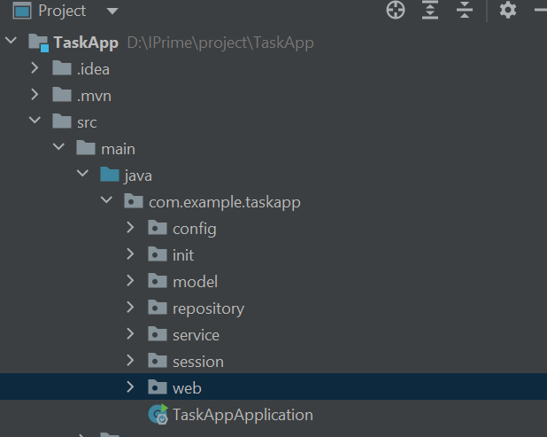

The project has 7 packages. ***Config*** – contains one Bean. ***Init*** – Initializes sample data like users, tasks. ***Model*** – contains entities, dtos. ***Repository*** – contains repositories with the queries. ***Service*** – all the logic is put in here. ***Session*** – contains one Bean annotated with SessionScope. ***Web*** – contains all the controller. Here are the pages:

***HOME PAGE***

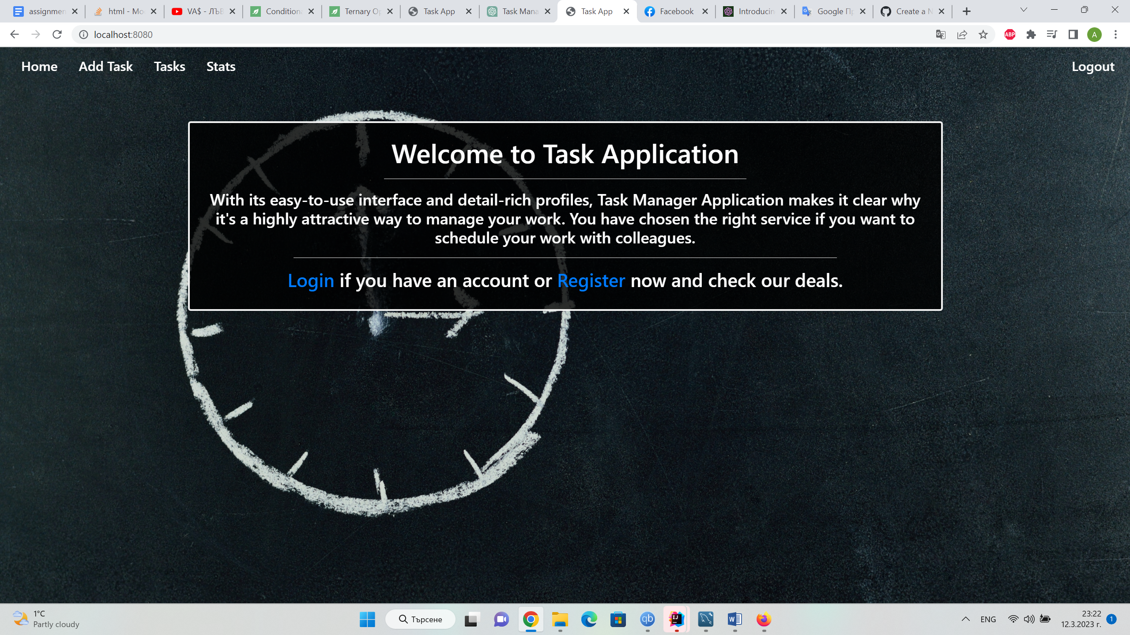

***TASKS PAGE***

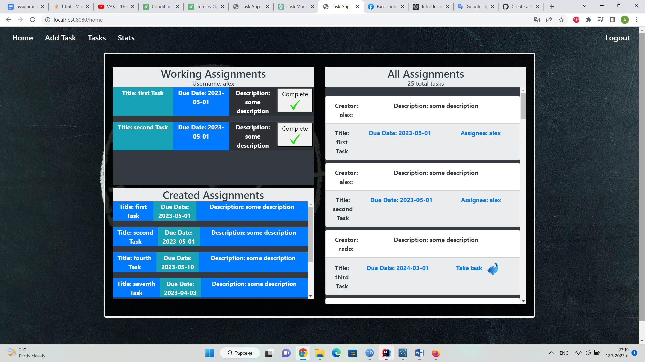

***STATS PAGE***

